SP3D PIPE SUPPORTS LABS
SP3D PIPE SUPPORTS LABS 1
1. Placing a Support by Structure 2
2. Placing a Support by point 5
3. Adding a Part to a Standard Support 9
4. Placing a Designed Support and Parts 12
5. Editing a Support 23
6. Deleting a Support 27
7. Using Place Linear Member Command 28
8. (Optional) Using Place Assembly Connection Command 29

1. Placing a Support by Structure
Place standard support by structure U Shaped Frame L2x2x1/8 w/o Baseplate, using the pipe
straight feature 2001-P and the beam on the steel structure that crosses above the pipe straight feature 2001-P. Using Toggle Connection to Structure, attach the structure to the bottom surface of the beam. The support should resemble the support below.

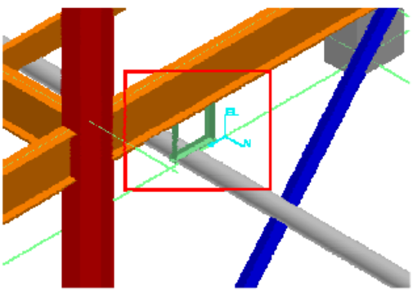

Before beginning the procedure:
Define your workspace to display Unit U02.
Make sure you are in the Hangers and Supports task and the Active Permission Group is set to Piping.

- Click the Place Support by Structure button on the vertical toolbar. The Place Support by Structure ribbon is displayed.
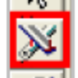
- In the select straight feature smartstep, select the pipe straight feature 2001-P that will be supported as shown.
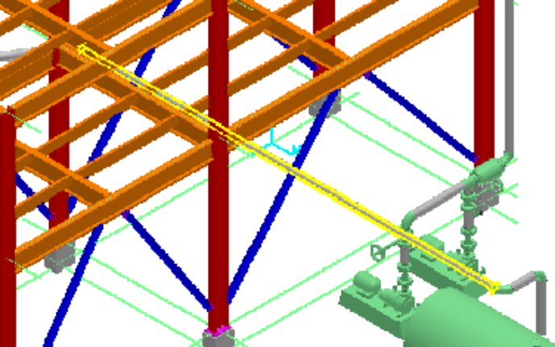
3. Click the Accept button on the ribbon to accept the selection and indicate that you are finished selecting the features to be supported. Make sure the Rule option is checked.
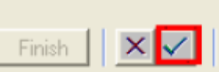 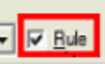

4. In the select structure smartstep, select the beam that crosses the pipe straight feature 2001-P
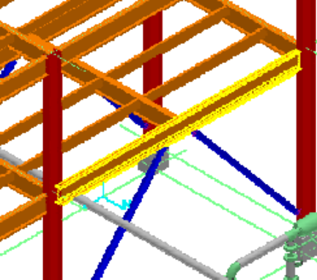

5. Click the Accept button on the ribbon to accept the selection and indicate that you have no more supporting structure for the support being placed.

6. From the Type drop-down list, select U Shaped Frame L2x2x1/8 w/o Baseplate.
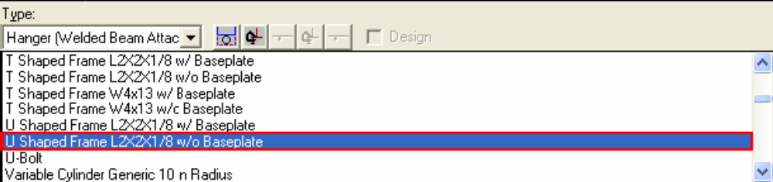

The support will now be constructed and displayed in wireframe, as shown.
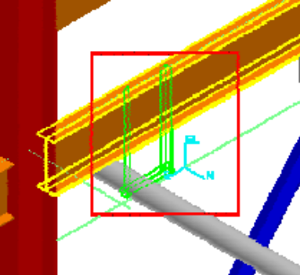

7. Click the Toggle Connection to Structure button to attach the structure to the bottom surface.
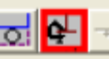

8. Click the Finish button on the ribbon to commit the support to the database.
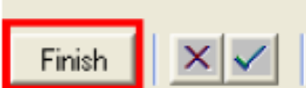

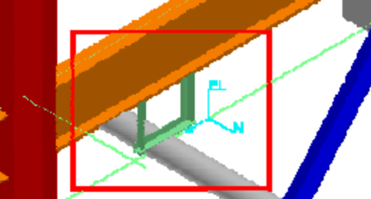

2. Placing a Support by point

Place a standard U Shaped Frame L3x3x1/4 w/Baseplate support supported by the slab Slab-1-0003 at a specific point on a pipe straight feature of pipeline 300-W. The Standard Support should resemble the highlighted support below.
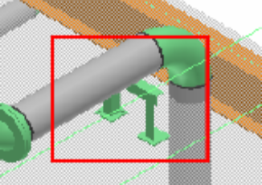

Before beginning the procedure:
- Define your workspace to display Unit U03 and coordinate system U03 CS.
- Make sure you are in the Hangers and Supports task and the Active Permission Group is set to Piping.

1. Click the Place Support by Point button on the vertical toolbar.
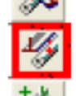
2. In the “select feature” smartstep prompt, select the pipe straight feature in pipeline 300-W that will be supported

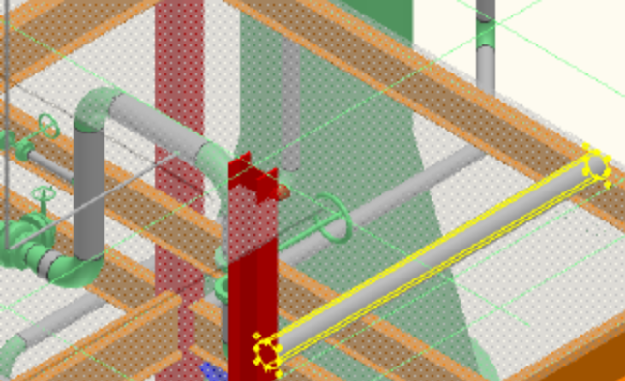
3. Click the Accept option on the ribbon to accept the selection and indicate that you have selected the features to be supported.
4. In the “select structure” smartstep, select the indicated slab Slab-1-0003 under the pipe straight feature of 300-W

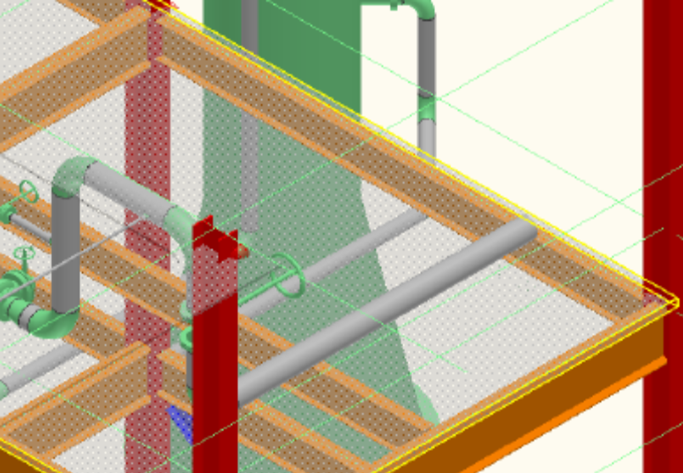

5. Click the Accept option on the ribbon to accept the selection of the slab Slab-1-0003 and indicate that you have no more supporting structure for the support being placed.
6. From the Type drop-down list, select the More… option to select the support to be placed from the Catalog.
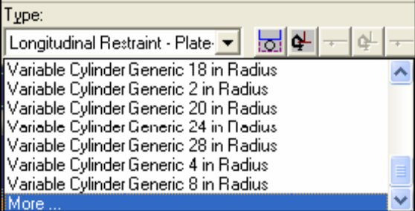

7. The Select Support dialog box appears. In this dialog box, expand the folder \Piping\HS Assembly\U Shaped Frames\Assy_FR_US_LS until you see the part Assy_FR_US_LS_3. Select the support part with the part description U Shaped Frame L3x3x1/4 w/Baseplate and click OK.
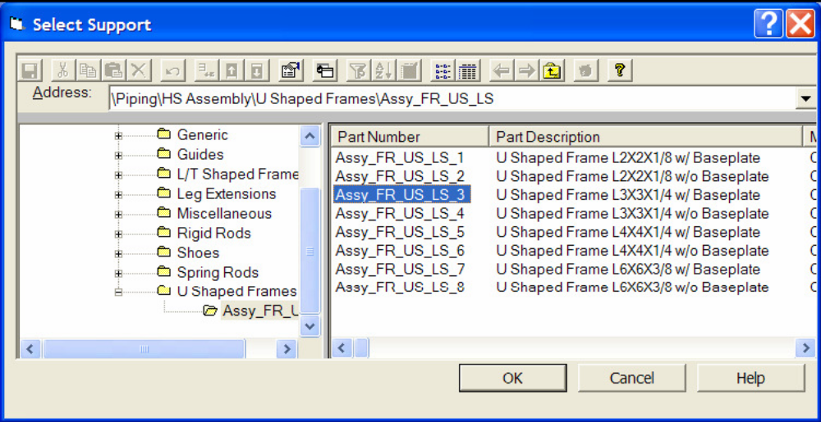
The selected support will appear in the graphic view, as shown.

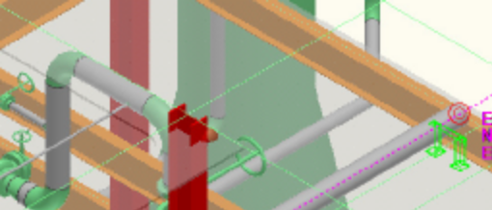

8. In the position smartstep, click to enter the exact placement point along the feature. The point you enter is projected minimum distance to the feature. You can use any of the precision point tools, PinPoint, Point Along, or SmartSketch keypoints to define your placement point.
In this case, position the support at a distance of 6 in from end of the elbow.
- Activate PinPoint and reset the target to the end of the pipe.
- Use the function key F7 to activate the North dimension and key in 6 in.
- Click anywhere in the graphic view
9. Click the Finish option on the ribbon to accept the placement of the support.

10. The command will now cycle to the position smartstep defaulting to all options you previously selected. You can change any options you wish and repeat step 8 to place another support, as shown.

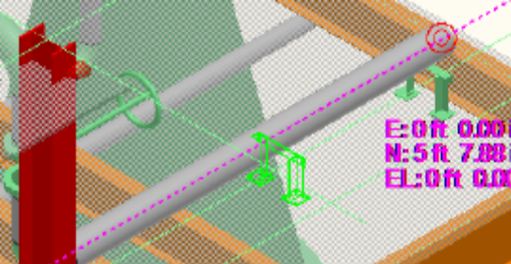

11. Terminate the Place Support by Point command by right-mouse click or picking the select command. The second support shown in dynamics will not be placed.

3. Adding a Part to a Standard Support

Place a support part, Anvil_FIG137_12, choosing the standard support as the parent. The resulting designed support is shown in the figure.
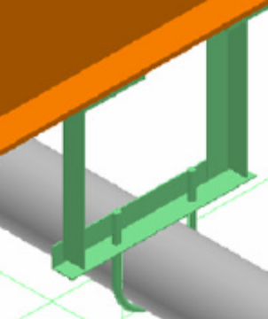

A standard support U Shaped Frame L2x2x1/8 w/o Baseplate by structure, should have been placed earlier by using the Place Support by Structure command. The placed support should resemble the highlighted support

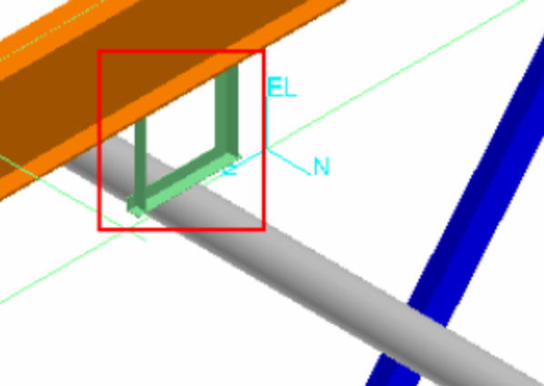

Before beginning the procedure:
- Define your workspace to display Unit U02.
- Make sure you are in the Hangers and Supports task and the Active Permission Group is set to Piping.

1. Click the Place Part button on the vertical toolbar. 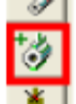

2. Select the standard support, U Shaped Frame L2x2x1/8 w/o Baseplate, in which you will place the new part, a U-bolt
The system prompts you with the following message:
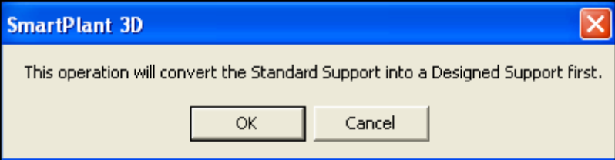
When you click OK, the system displays the Select Part dialog box.
3. In the Select Part dialog box, select expand the folder to \Parts\Anvil\PipeClamps\Anvil_FIG137 until you see that part Anvil_FIG137_12. Select the part Anvil_FIG137_12 to add it to the support.
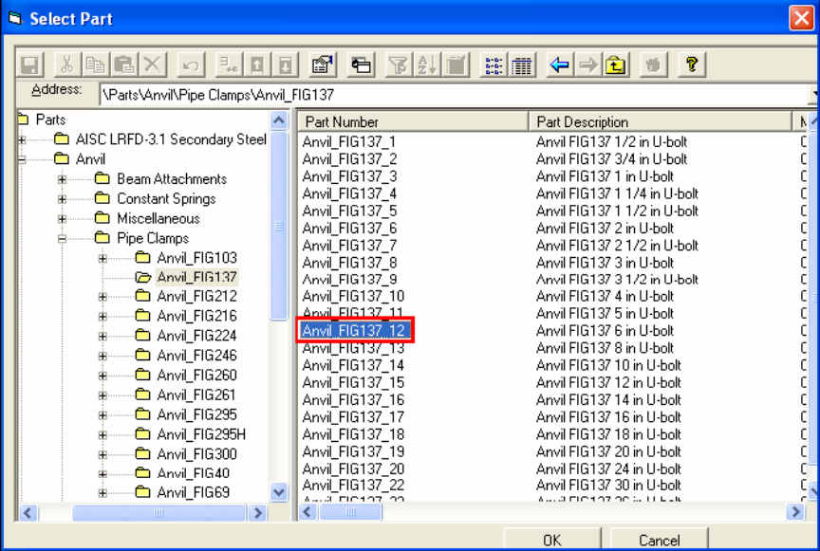

4. Position and orient the selected part, Anvil_FIG137_12
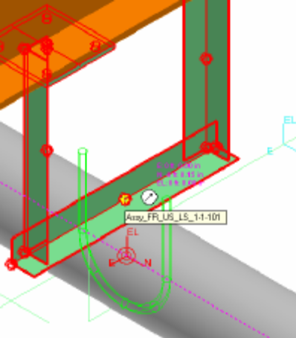

5. Lock to the axis of the pipe with SmartSketch middle-mouse lock and then locate the designed support key point located at the center of the pipe.
6. After positioning, click the Rotate button on the Common toolbar to rotate the part by 90deg.
Tips:
- You can toggle the placement point for the part by clicking the Toggle Port option on the Place Part ribbon. Use the U-bolt port located at the center of the radius.
- If you are having trouble locating the key point of the designed support, toggle the SmartSketch surface locate option off by pressing F3 on the keyboard. F3 will toggle the surface locate option back on when you need to locate points on surfaces.

4. Placing a Designed Support and Parts

Place a designed support on pipeline 2001-P and then manually select and position the individual parts of the support. The resulting support will resemble the figure.
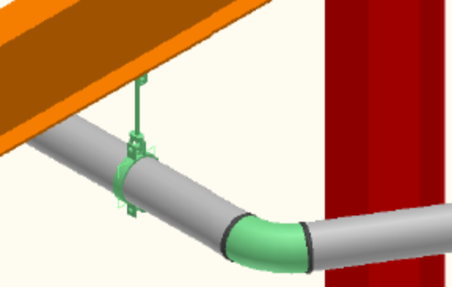

Before beginning the procedure:
- Define your workspace to display Unit U02.
- Make sure you are in the Hangers and Supports task and the Active Permission Group is set to Piping.

1. Click the Place Support by Structure button, select the Design check box, and then locate the same straight feature in pipeline 2001-P that you selected for the support in the previous exercise.
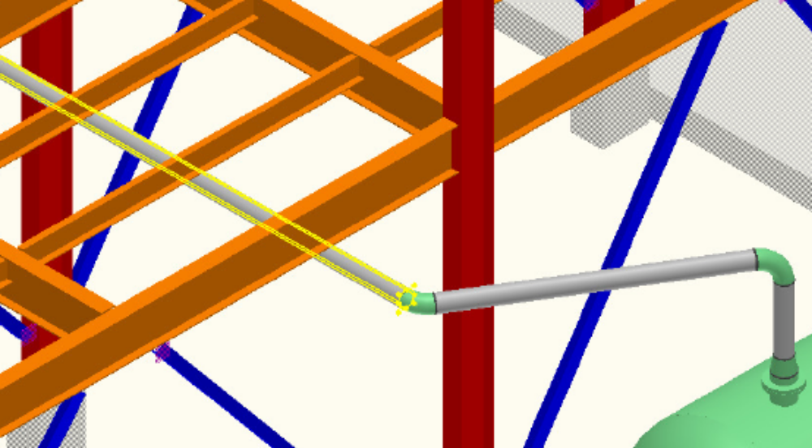

2. Click the Accept button on the ribbon to accept the selection and indicate that you have selected the feature to be supported.
3. Select the crossing beam and accept the one selection. The highlighted green rectangle is the graphic for designed supports. Click Finish to commit the designed support to the database.

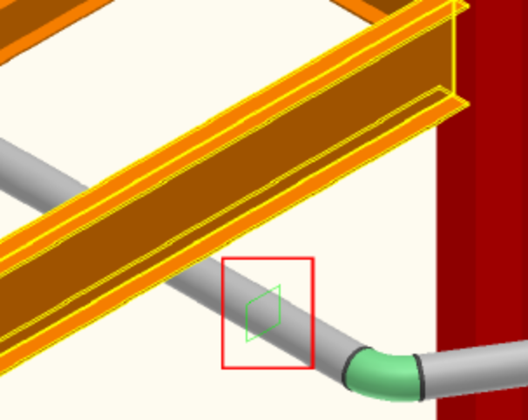
Note:
 In the current version of the software, you may need to reset the Target by using the PinPoint ribbon before placing a part.
4. Click the Place Part button on the vertical toolbar to open the Select Part dialog box and then, expand the folder \Parts\Anvil\PipeClamps\Anvil_FIG212 to select a pipe clamp, Anvil_FIG212_12 for the 6 in diameter pipe.
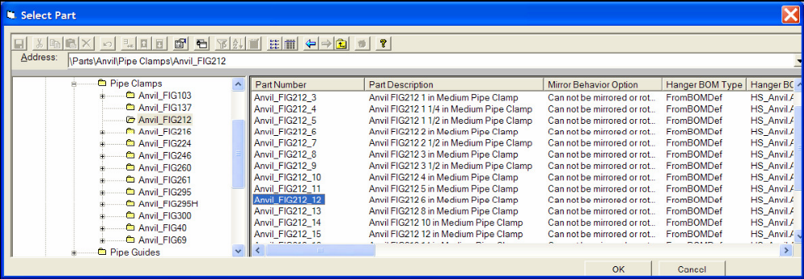
5. Position the pipe clamp at the designed support key point and use the Rotate command to orient the part on the pipe.
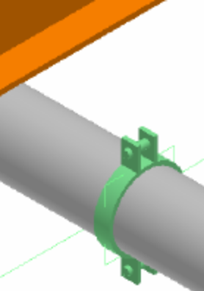
6. Click the Place Part button and select a rod fitting Anvil_FIG290_4 under \Parts\Anvil\Rod Fittings\Anvil_FIG290 folder.
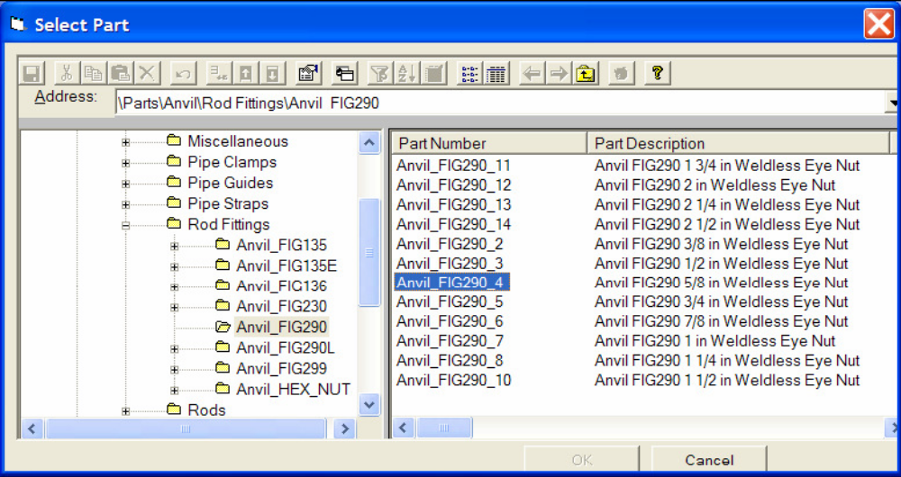
7. Click the Toggle Port option on the ribbon to choose the port to connect the pipe clamp. Position relative to the appropriate key point on the pipe clamp.
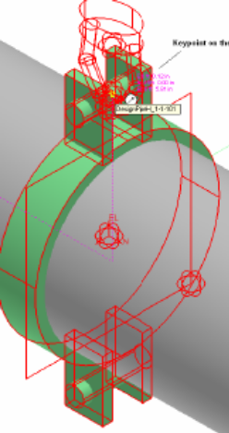

8. Click the Place Part button and select the rod, Anvil_FIG140_4 under \Parts\Anvil\Rods\Anvil_FIG140 folder.
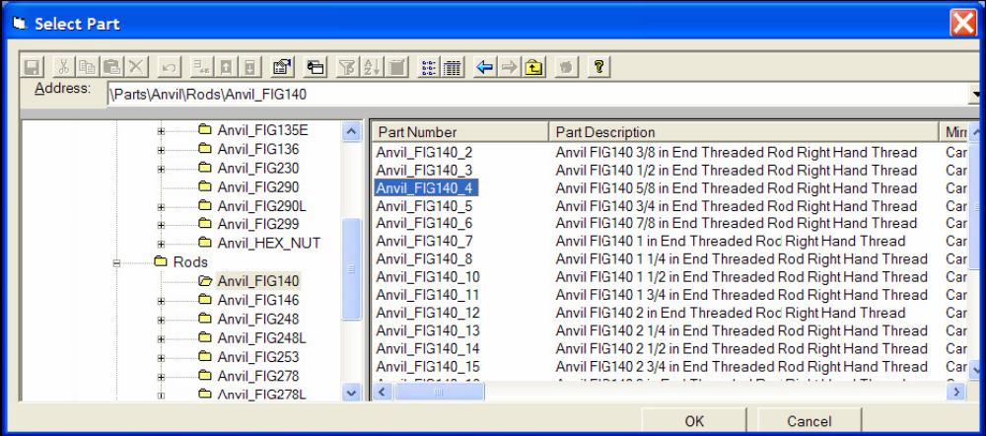

Tips:
- This part is a type whose length is defined by the identification of two points during placement. You are prompted to locate these points after you select the part.
-  Locate key points on the support parts and structure when you position the part.
- When you select the type of support parts that stretch, the Edit ribbon for the part will show the Stretch option. When you click the option, you can edit the location of the ends of the part. The Toggle Port option appears when you select the Stretch option. This allows you to choose the port of the stretchable part you want to move.

9. Enter two points to place the rod. One point on the rod fitting (eye nut) and one point in space vertically above the first point (locate the vertical axis with SmartSketch and click).
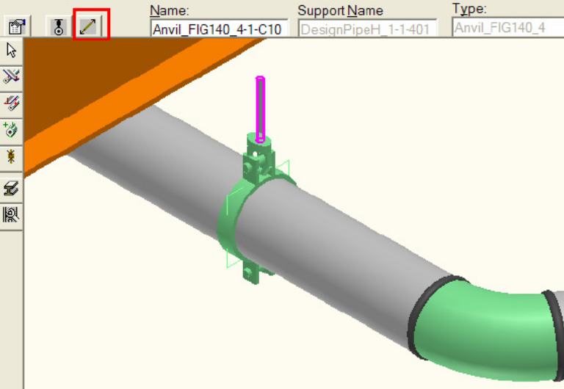
10. Rotate the view so that you can click the bottom surface of the beam. Use PinPoint to lock the East and North coordinates to the location at the end of the rod and then select the surface of the beam.
11. Click the Place Part button and select a <BEAM ATTACHMENT FIG 66_4>
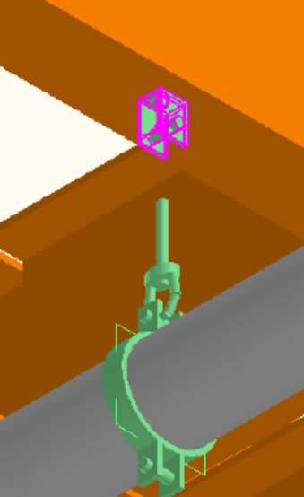
11.5 rod fitting Anvil_FIG290_4 under \Parts\Anvil\Rod Fittings\Anvil_FIG290 folder. Position relative to the appropriate key point on the beam attachment.
12. Select the rod and then select the Stretch smartstep on the Edit ribbon. Select the key point on the beam attachment to define a new length for the rod.
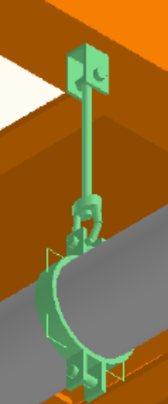
Notice that the beam attachment in the figure should be rotated to give free movement in direction of the pipe expansion. Select the beam attachment part you placed in the previous exercise and rotate it 90 deg to give the result shown in the figure below
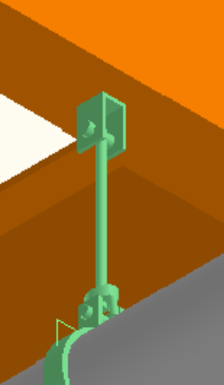
Tips:
- The Rotate command automatically sets the origin of the rotation to the origin of the hanger part. In this case, the origin is at center of the beam attachment.
- Make sure the vertical axis is highlighted as the axis of rotation.
- It is much easier, of course, to have standard supports that position and orient the parts automatically.

In the next example, place a lug on an elbow that is rotated relative to the unit’s auxiliary coordinate system. The example is chosen to illustrate the manipulation of the part’s position using the Move and Rotate commands and the key points of the part. The end result of the designed support and single part placement is shown in the figure
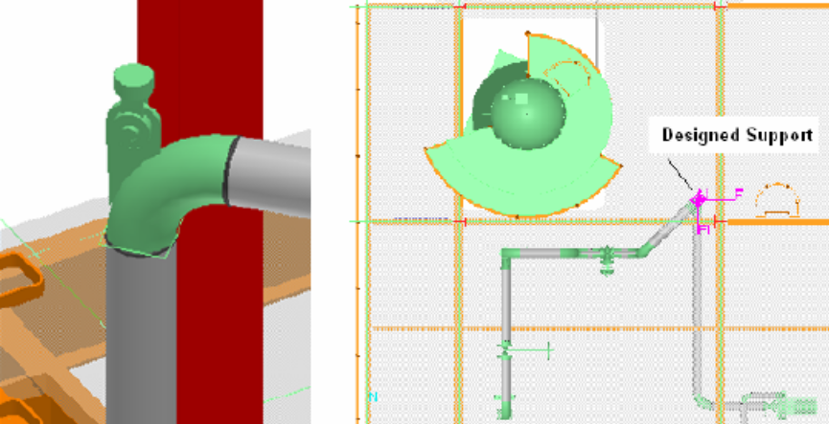

1. Define your workspace to include system A2 > U03
2. Make sure you are in the Hangers and Supports task and the Active Permission Group is set to Piping.
3. Place a designed support by point selecting the elbow on pipeline U03/Water/300-W, as shown
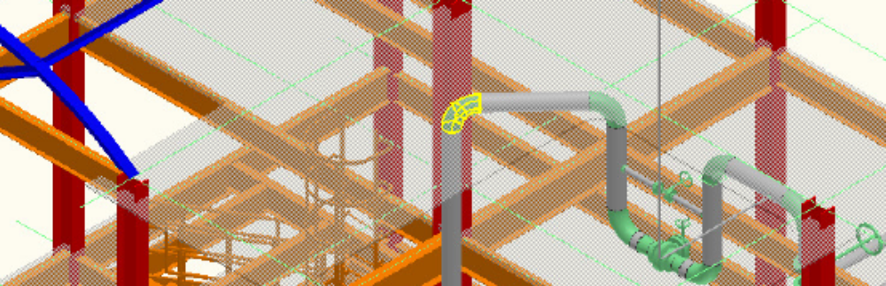
4. Select the slab as the supporting structure, as shown
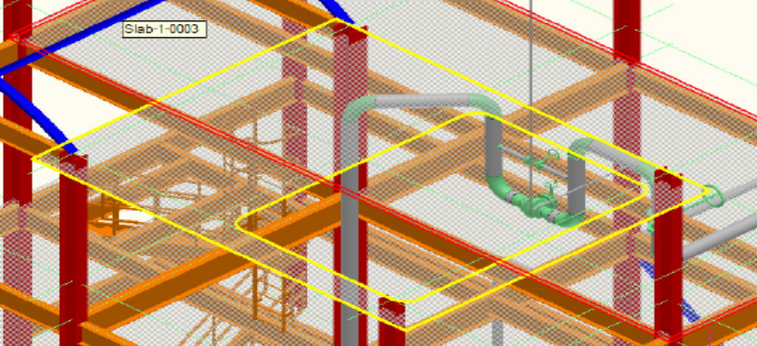
5. Position the designed support at the vertical port face of the elbow.
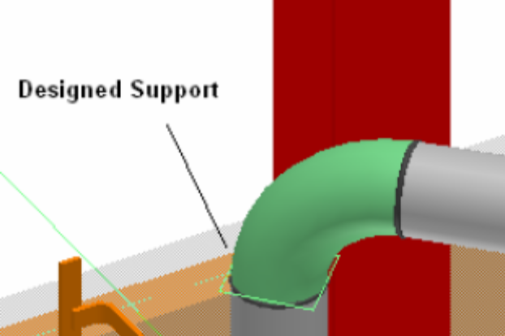
Tips:
- Notice that the helper graphics for the designed support are oriented with the plane of the elbow. These graphics can be used to help position parts during placement.

6. Create a temporary coordinate system for PinPoint by using the By Three Points method and align the Easting (x) axis with the pipe centerline and the Northing (y) in the Global Up direction. This will help cause the lug to default to a vertical position.
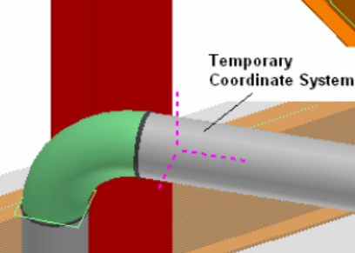
Tips:
- Optionally, you can reposition the target of the active coordinate system to the face of the elbow same as where the designed support sits.
- Parts are placed by default, oriented with the active coordinate system axes. The lug should default to the orientation of the temporary coordinate system
- When selecting the points for the temporary coordinate system, toggle the surface locate off by using the F3 function key. This will prevent SmartSketch from locating the surface of the slab. Optionally, you can hide the slab.

7. Click the Place Part button, when prompted select the designed support you just created. Then select the Parts/Utility/Miscellaneous/HgrElbowLug part class.
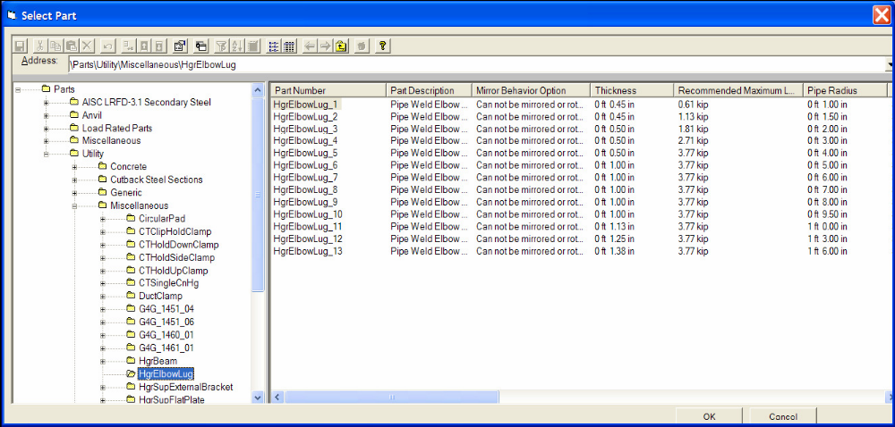

8. Select the specific part, e.g. HgrElbowLug_6 (since piping nominal radius is 5”). Click the Support Properties smartstep on the placement ribbon and enter the radius of the long-radius elbow (1.5 x NPD = 15” = 1’ 3”) in the Bend Radius dimension property of the lug and OK.
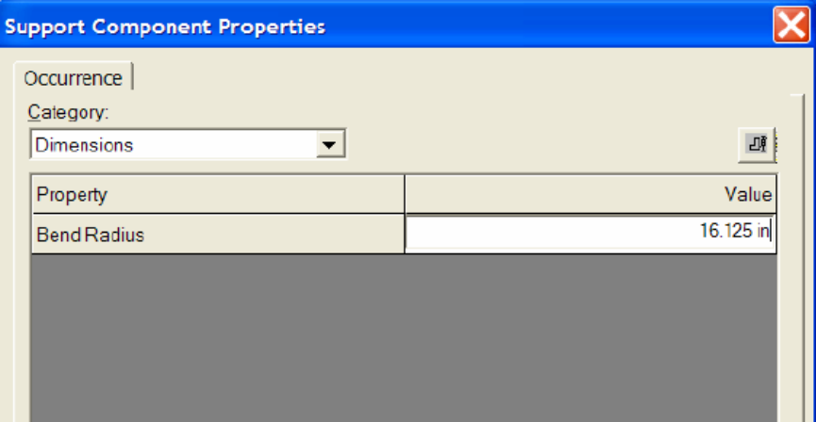

9. Toggle the key point port being used for placement from the center of radius to the point that corresponds to the horizontal port of the elbow. Normally this implies a couple of clicks on this button, the first one attempts to place the lug by the top part.
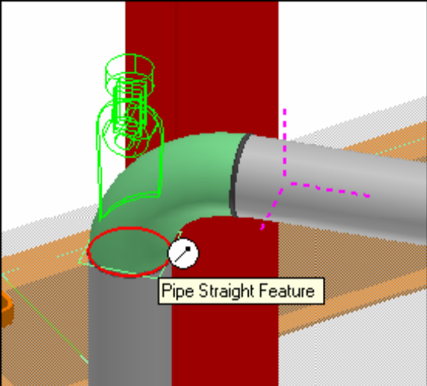

10. Place the lug by clicking on the keypoint as shown above at the end of pipe/elbow. This is sometimes easier from a plan view.
- (Optional) Click the Rotate button on the Common toolbar to rotate the part into alternate possible positions. The default rotation point is the origin of the part’s local coordinate system. In this case, this is not the desired rotation point. Select the Axis Position Point toggle to move the rotation point. Select the port of the elbow (or the end of the straight feature) as the rotation point. The rotation axis is highlighted. You can change the rotation axis by selecting in the Axis direction drop-down list or selecting the axis or another linear element in the graphic view.

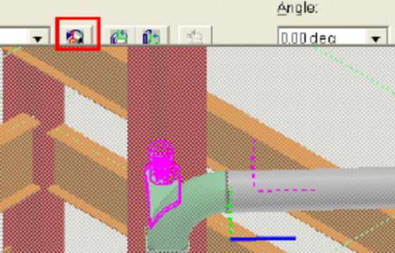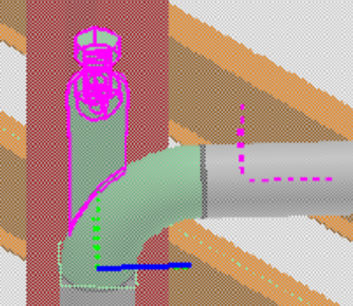

5. Editing a Support
You will extend the U-frame pipe support, U Shaped Frame L2x2x1/8 w/ Baseplate, to include an additional pipe.
Note: The new pipe supported is just used for this example and is not part of the training plant. If not there, request help from the instructor placing the copy parallel pipe 10in west of the long sloping pipe in Unit 02 pipeline 2001-P. You can delete it later.

Before beginning the procedure:
- Define your workspace to display Unit U02.
- Switch to the Hangers and Supports task

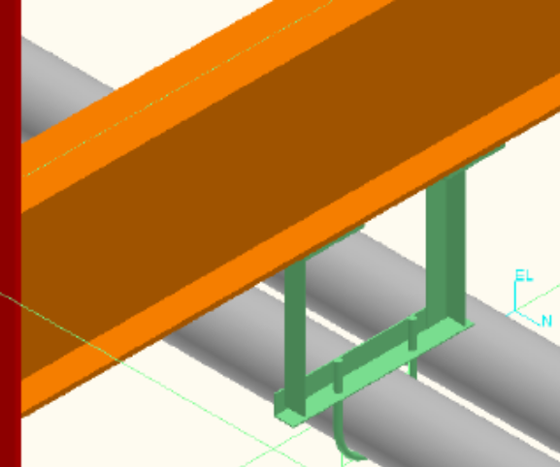

1. Set the filter to Support option in the Locate Filter drop-down list.
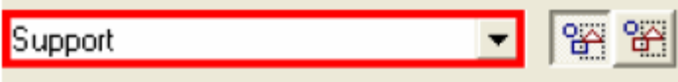

2. Select the standard U-frame support that is nested under the designed support, select the select straight feature smartstep, and select the straight feature of the new pipe run to add it to the support. Accept the selection and click Finish.

Notes:
- Before clicking Finish, make sure the original designed support is still the system parent of the standard support.
- Adding the straight feature to the standard support repositions the support and adds key points at the center of the pipe. You will use this keypoint later to position another U-bolt.

3. Click the Settings option on the Support Placement ribbon to edit the properties of the support.
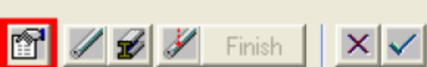
4. The Support Properties dialog box is displayed. Change the span of the support to 2ft, and click OK.
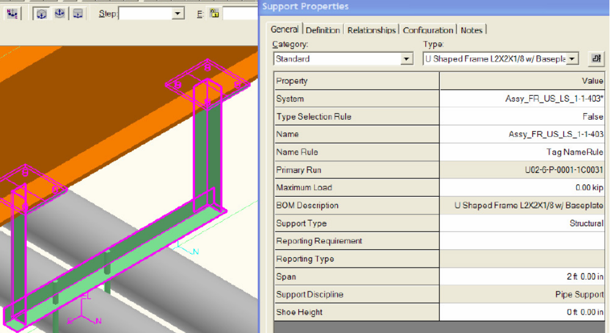
Notes:
- You can specify options to include pipe support parts in the same spool as the components to which they are welded. The supports must have the Fabrication Requirement property set to By fabricator, the Fabrication Type set to Shop fabricated, and the Fabrication Responsibility set to By Piping. These properties are set in the Support Properties dialog box under the Fabrication and Construction and the Responsibility categories on the General tab.
- Your Catalog administrator can set defaults on your supports so that supports that include parts welded to the pipe are always placed with these property values set.

You can copy and paste an entire support or just a support part. Copy the U-bolt in the designed support of the previous exercise to the adjacent pipe, as shown
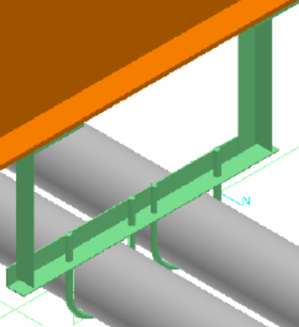
1. Set the filter to Support Component in the Locate Filter drop-down list.
2. Select the U-bolt (part number U Bolt Anvil_FIG137_12).
3. Click the Copy command.
4. The Copy command prompts you to select the reference point within the selected set of objects. Select the key point located where the pipe and the support touch.
5. Click the Paste command to paste the objects.
6. The Paste dialog box appears. In this dialog box, you define inputs needed by the objects you are pasting. All design objects will at least require a system parent. In this case, paste the U-bolt to the same parent designed support system. Make sure that the Paste in place option in the Paste dialog box is cleared to paste the copied objects in different location. Click OK.
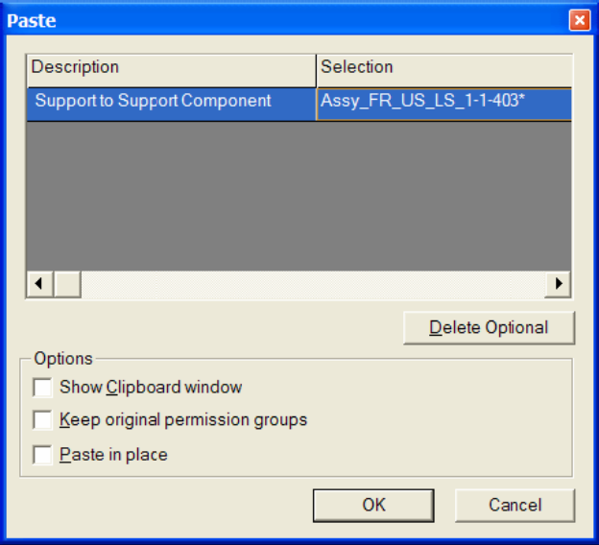

You can change the system by highlighting it in the Paste dialog box and selecting a different support system from the Workspace Explorer. The parent system will be highlighted in the Workspace Explorer corresponding to the selection in the Paste dialog box.

7. Paste the U-bolt using the keypoint of the U-frame support located where the pipe and the support touch.

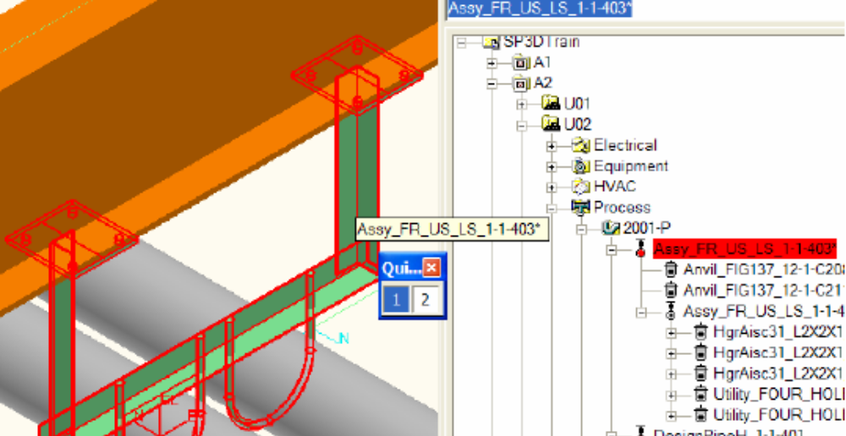

6. Deleting a Support

Delete the designed support you have just created.
1. Select the Support option in the Locate Filter drop-down list.
2. Position your cursor over the U-frame support and pause. The QuickPick dialog box displays. Highlight the options and select the designed support. The designed support is the system parent of the U-frame assembly and the two U-bolt parts.

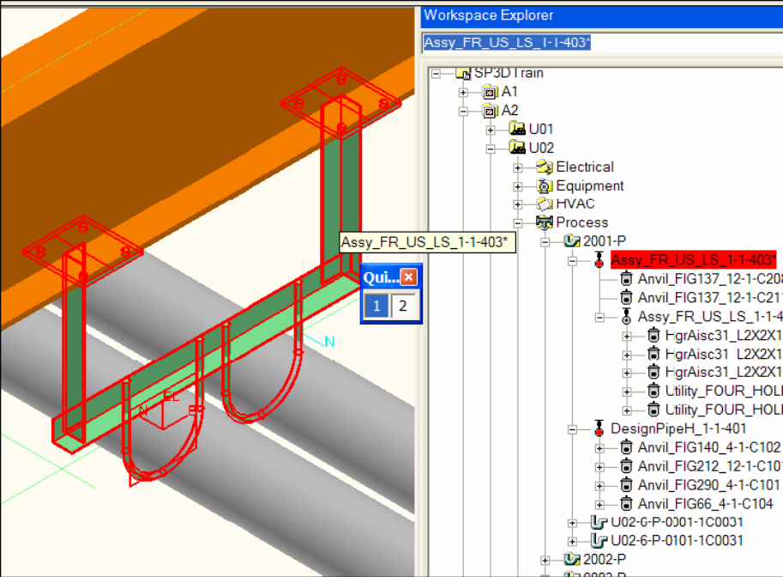

3. Click the Delete button on the Common toolbar to delete the designed support and all objects nested in the system hierarchy under it.
4. Set your select filter to All and select the pipe run you created in this exercise and delete it.
For more information related to supports, refer to the user guide HangersSupportUsersGuide.pdf.

7. Using Place Linear Member Command

Use the Place Linear Member command to create a basic frame anywhere on an existing beam as shown using section L2X2X1/4. Place the middle member at the midpoint on the vertical L’s.
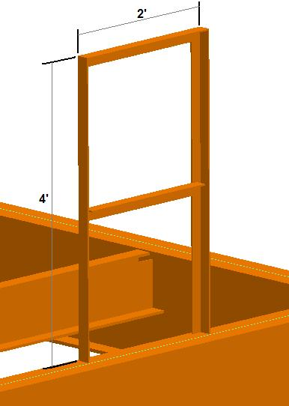
Tips
Use Cardinal Point, Angle and Reflect features to manipulate the orientation of the L frame members.
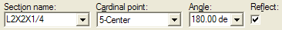
SmartPlant views these items as structural members, rather than supports. To edit frame members after placement, change tasks to Structure, where you are able to select any of these members for modifications. Otherwise Delete (using “All” filter setting) or Undo the problem parts and place again.

8. (Optional) Using Place Assembly Connection Command

Use the Place Assembly Connection command to detail the top connections on the basic frame.

